**DAILY ONLINE ACTIVITIES SUMMARY**

|  |  |  |  |  |  |  |  |  |
| --- | --- | --- | --- | --- | --- | --- | --- | --- |
| **Date:** | **23-05-2020** | | | | | **Name:** | **Sannidhi P** | |
| **Sem & Sec** | **8th sem B sec** | | | | | **USN:** | **4AL16CS084** | |
| **Online Test Summary** | | | | | | | | |
| **Subject** | | **-** | | | | | | |
| **Max. Marks** | | **-** | | **Score** | | | **-** | |
| **Certification Course Summary** | | | | | | | | |
| **Course** | **JAVASCRIPT Tutorial** | | | | | | | |
| **Certificate Provider** | | | **SOLOLEARN** | | **Duration** | | | **30min** |
| **Coding Challenges** | | | | | | | | |
| **Problem Statement:**  TRIANGULAR NUMBER SERIES(Write a c program to display first N triangular numbers) | | | | | | | | |
| **Status: completed** | | | | | | | | |
| **Uploaded the report in Github** | | | | | **yes** | | | |
| **If yes Repository name** | | | | | **Sannidhi1** | | | |
| **Uploaded the report in slack** | | | | | **yes** | | | |

Online Test Details: (Attach the snapshot and briefly write the report for the same)

Test was postponed to 24 may

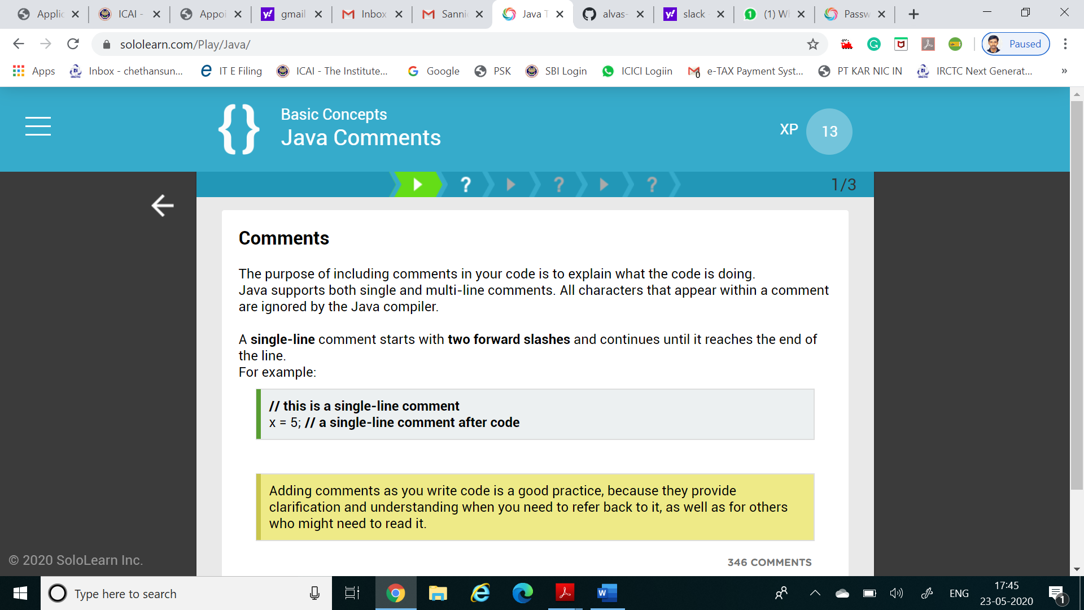

Certification Course Details: (Attach the snapshot and briefly write the report for the same)

Coding Challenges Details: (Attach the snapshot and briefly write the report for the same)

Coding was given n it was uploaded for github and slack

PROGRAM1

include <stdio.h>

void triangular_series(int n)

{

for (int i = 1; i <= n; i++)

printf(" %d ", i*(i+1)/2);

}int main()

{

int n ;

printf("Enter value for n");

scanf("%d",&n);

triangular_series(n);

return 0